**Gravitation & Satellites**

A force of attraction exists between any 2 particles that have mass.

Field theory: At any point in space the gravitational acceleration experienced by an object is equal to the sum of each of the contributions from different masses.

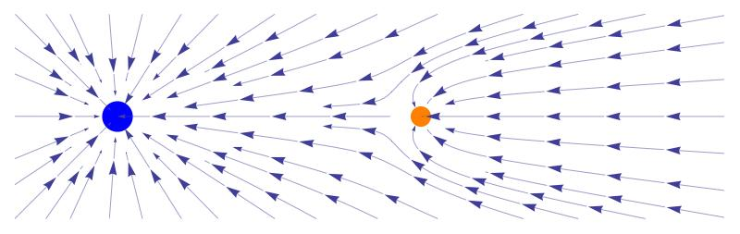

Law of universal gravitation:

Any 2 bodies attract each other with a force that’s proportional to the product of their masses and inversely proportional to the square of their distance apart”.

Fg =

Where:

* F is force of attraction (N).
* M1 and M2 are the masses of the 2 objects (kg).
* d is distance between their centres of mass (m).
* G is the Universal Gravitational Constant (6.67 x 10-11 Nm2kg-2).

A large object creates a gravitational field around itself.

g = $G\frac{M_{1}}{d^{2}}$ where M1 is the mass of the large object.

This value is also the gravitational acceleration experienced by a object at this point.

FW =

Where:

* ME is mass of the Earth (object producing the gravitational field).
* d is distance between the centres of mass of the object of mass MX and the Earth.

For objects in circular orbit, the centripetal force that causes circular path is the gravitational force of attraction.

Circular orbit: F = $G\frac{M_{1}M_{S}}{r^{2}}$ = $\frac{M_{S}v^{2}}{r}$

Where:

* MX is mass of object in orbit (e.g., satellite).
* M1 is mass of the astronomical body.
* r is radius of the orbit.
* v is tangential velocity of object in orbit (e.g., satellite).
* G is the Universal Gravitational Constant (6.67 x 10-11 Nm2kg-2).
* Gravitational fields can act at a great distance and their force isn’t affected by objects in their path.
* Gravitational fields exert a force on masses and hence they can be detected and measured by the influence they have on a unit mass.
* The strength of a gravitational field (g) is defined as the force exerted on a unit mass.

g = $\frac{F}{m}$

Variations in the value of g:

* Variations in the density of the Earth’s crust.
* Uneven shape of the Earth causing variations in the radius.
* The value of g decreases as we leave the Earth’s surface proportional to the square of the distance from its centre.

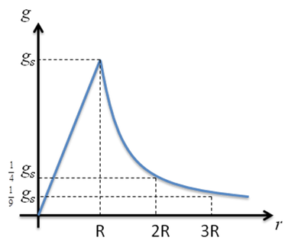

Motion on inclined planes:

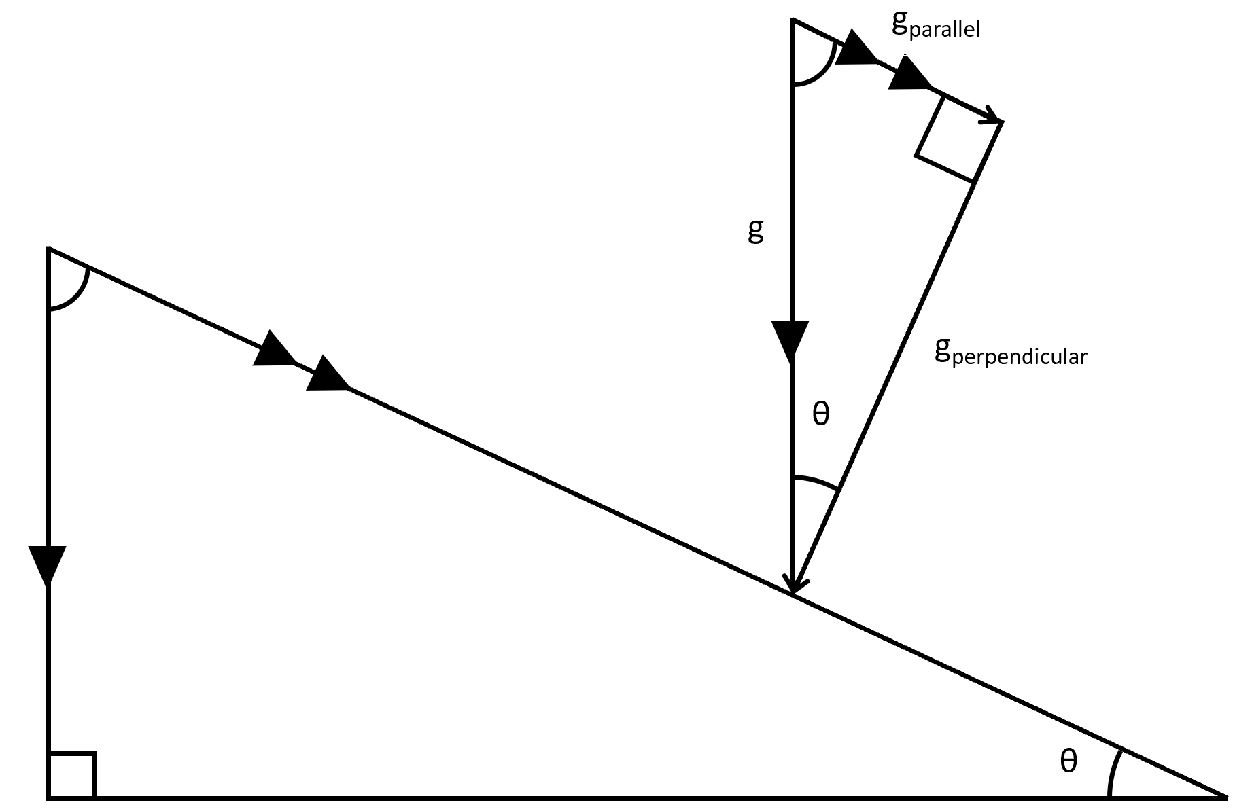

Kepler’s First Law: The planets move in an elliptical orbit with the Sun at its focus.

Kepler’s Second Law: The line connecting a planet to the Sun sweeps out equal areas in equal intervals of time.

Kepler’s Third Law: For every planet orbiting the Sun, the ratio of the cube of the average orbital radius to the square of the period of revolution is the same.

$$F_{g}=F_{c}$$

$$G\frac{Mm}{r^{2}}=\frac{{mv}^{2}}{r}$$

$$G\frac{M}{r}=v^{2}$$

$$v=\frac{2πr}{T}$$

$$v^{2}={\left(\frac{2πr}{T}\right)}^{2}=\frac{4π^{2}r^{2}}{T^{2}}$$

$$G\frac{M}{r}=\frac{4π^{2}r^{2}}{T^{2}}$$

$$GM=\frac{4π^{2}r^{3}}{T^{2}}$$

$$T^{2}=\frac{4π^{2}r^{3}}{GM}$$

Other things that aren’t part of the proof:

$$\frac{T^{2}}{r^{3}}=\frac{4π^{2}}{GM}$$

$$\frac{4π^{2}}{GM} is constant$$

$$∴If object A and object B are orbiting around the same object:$$

$$\frac{{T_{A}}^{2}}{{r_{A}}^{3}}=\frac{{T_{B}}^{2}}{{r_{B}}^{3}}$$

$$i.e., the ratio of the orbital period cubed to the orbital radius$$

$$squared for any object orbiting the same body is constant$$

$$\frac{{T_{A}}^{2}}{{T_{B}}^{2}}=\frac{{r_{A}}^{3}}{{r_{B}}^{3}}$$

$$i.e., The ratio of the orbital period cubed of any 2 objects orbiting the same$$

$$body is equal to the ratio of the orbital radius squared of the 2 objects$$

**Set 5**

Q: If all objects are attracted to one another by gravity, why aren’t you attracted towards large buildings?

You are attracted to large buildings. Unfortunately, the mass of yourself and the large building is not large enough to create a measurable force.

**Q: When mountaineers climb Mount Everest to a height above 8km does their weight change? Explain.**

Yes their weight does change but not by much. The increase in radial distance from the centre of the planet is not large enough to produce a measurable effect or an effect that is noticeable to the brain of the climber. Radius goes from 6.37 x 106m on Earth’s surface to 6.378 x 106m on Mount Everest so their weight would decrease by a very small amount due to this slightly increased distance.

**Q: How does the weight of an underground miner change as he descends into a very deep mine? Explain.**

The weight of an underground miner decreases as they descend into a mine, though the effect is not easily measured. The reason that this occurs is that as you descend into the Earth, the Earth above you attracts you upwards slightly while the Earth below you continues to pull you down, though to a slightly reduced extent. If you were able to descend to the centre of the Earth you would eventually become weightless because you would have equal quantities of matter all around you, pulling you equally in all directions. The universal gravitational law does not operate below the surface of the Earth. Instead the gravitational field drops to zero linearly as you move from the surface of the Earth to its centre.

**Q: A geophysicist’s assistant measures the acceleration due to gravity with a very sensitive accelerometer at various places on the Earth’s surface and finds that it’s slightly different at each place. What are 2 possible reasons for this variation?**

The density of the Earth is not uniform. More dense rocks (rocks that have more mass per unit of volume they take up) in the crust will give a stronger gravitational reading than lighter rocks. Also, the Earth is not perfectly spherical, and its radius differs at different locations around its surface, leading to higher readings of the acceleration due to gravity where the radius is smaller.

**Q: What’s the weight of a freefalling object? Explain.**

The object has weight (mg). The object appears weightless as it begins to fall because there are no other forces acting on it. The perception (feeling) of weight is due the presence of other forces such as normal force or air resistance opposing the weight force. The falling object will continue to ―feel weightless until it approaches terminal velocity, and the air resistance force becomes appreciable. The air resistance force will then provide the other force that will allow you to feel your weight.

**Q: If air resistance is negligible, all freefalling objects near the Earth’s surface accelerate at the same rate even though they have different masses. Explain.**

The acceleration of an object is not determined by the mass of the object. It is determined by the mass of the planet (other objects) that is making (generating) the gravitational field (g = $G\frac{M_{1}}{d^{2}}$).

**Q: Black holes form when massive stars at least 4x the mass of the Sun collapse into a tiny fraction of their original volume. Why’s the gravitational force near a black hole so large that not even light can escape from it even though its mass is the same as that of the original star?**

F = $G\frac{M_{1}M_{2}}{d^{2}}$

This formula can only be applied outside of the star‘s surface. Inside the star, a different formula holds true. If the volume of the star is reduced however without altering the stars mass, the edge of the star becomes closer to the centre of the star and the formula above will still hold true for longer until you pass below the star‘s surface.

Decreasing the volume of an object without altering its mass increases the density of the object (ρ = $\frac{M}{V}$ → ρ ∝ $\frac{1}{V}$).

As r decreases, the size of the force (and consequently gravitational field) increases (F ∝ $\frac{1}{d^{2}}$). If r is small enough without going inside the stars surface, the strength of gravitational field will be so great that not even light can escape.

**Q: The Moon is in an almost circular orbit around the Earth. Why doesn’t the gravitational force of the Earth acting on the Moon change the Moon’s speed?**

The Moon’s moving at a velocity that provides sufficient centripetal force for the Moon to remain in circular orbit. The gravitational force of the Earth has no component in the same direction as the Moon’s velocity and so can’t affect the Moon’s velocity.

= → v2 =

G, ME and r are constant and so velocity remains constant.

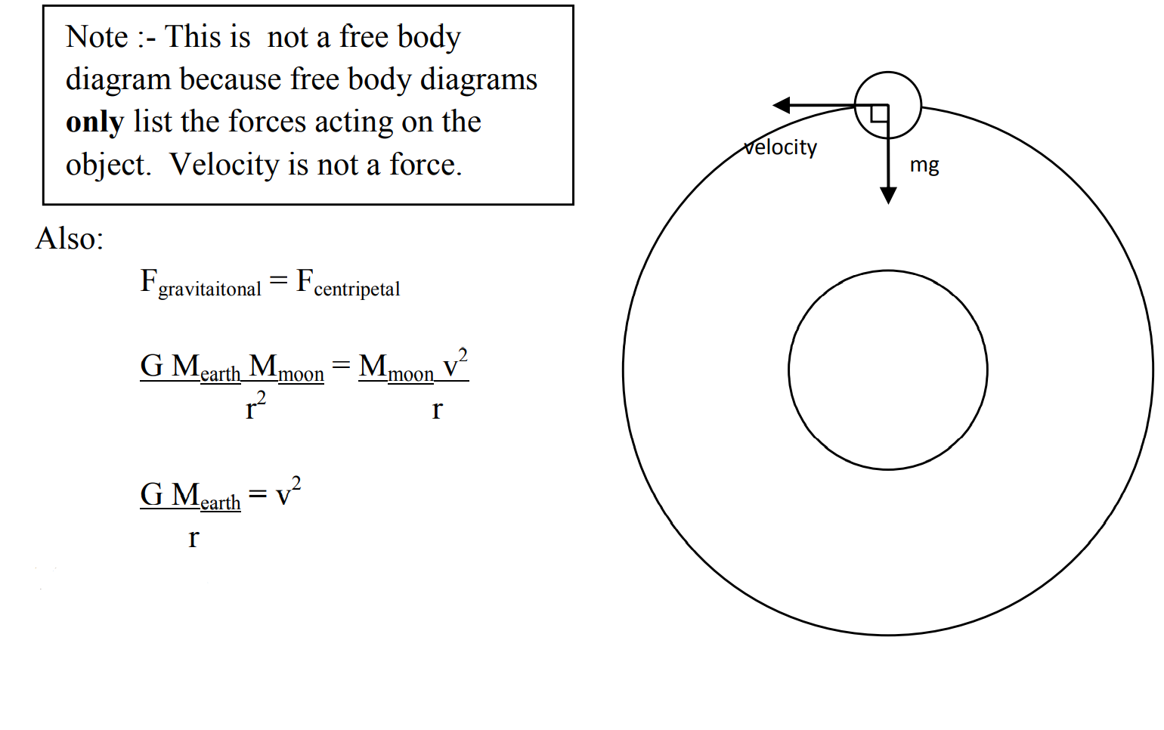

**Q: Which is greater., the period of revolution of a communications satellite at a heiht in excess of 30000km or that of a satellite that orbits at a height of a few hundred kilometres? Show your reasoning.**

The greater the distance the longer the period. According to Kepler‘s law $\frac{r^{3}}{T^{2}}$ = $\frac{gm_{p}}{4π^{2}}$ as r gets bigger T also gets bigger since $\frac{gm_{p}}{4π^{2}}$ is constant. T2 ∝ r3 so a satellite orbiting at a height in excess of 30,000 km will have the greater time period.

**Q: A research satellite in low Earth orbit moves across the Earth’s surface at several kilometres per second. If engineers fired retrorockets on board this satellite and slowed it down quickly, what would happen to the satellite’s orbit?**

The satellite‘s orbit would change from circular to elliptical. The balance between the speed of the satellite and the centripetal force has been broken. If a constant retarding force is encountered such (as the Earth‘s atmosphere), the pathway taken by the satellite will become an inward spiral (death spiral).

**Q: Communications satellites are always located above the same spot on the Earth’s surface, that is, their speed across the Earth’s surface is zero. Why do they remain in orbit?**

The satellite‘s period of revolution is matched to the period of the Earth‘s rotation. This is achieved using Kepler‘s law $\frac{r^{3}}{T^{2}}$ = $\frac{gm_{p}}{4π^{2}}$ to calculate the correct distance above the earth to park the satellite in order to achieve an orbital period equal to 24 hours. The satellite does not fall back to earth because its rate of acceleration towards the Earth, is counterbalanced by its rate movement (velocity) away from the Earth at a tangent.

**Q: Why do engineers launch rockets carrying satellites in an easterly direction?**

To move a satellite into orbit it is necessary to increase the gravitational potential energy of the satellite. This is done by giving the satellite kinetic energy, usually provided by a rocket. The calculation according to the law of conservation of energy begins to look like:

Ep(at Earth’s radius, rEarth) + EK(rocket) = Ep(at rEarth + altitude)

An object on the equator already has some kinetic energy due to the revolution of objects on the Earth‘s surface as compared to an object at a geographic pole (just rotating). This means a satellite on the equator needs less supplementary (extra) kinetic energy to get it into orbit. This is why the USA‘s space agency is in Florida on the equator.

The Earth rotates towards the East. If the rocket is shot in the opposite direction to the rotation of the Earth (west) you are actually removing the kinetic energy that the Earth has given to the satellite. If the rocket is shot in the same direction to the rotation of the Earth (west) you are adding to the kinetic energy that the Earth has given to the satellite, almost like a catapult effect. This is what you want.

**Q: Why do engineers try to locate launch facilities as close to the equator as they can?**

The speed of rotation of the earth is at a maximum at the equator and so the kinetic energy given to the rocket / satellite by the Earth‘s rotation is also at a maximum. It will require less rocket fuel to make up the extra kinetic energy required to get the satellite into orbit.

**Q: Scientists aboard an orbiting space station ant to return some equipment to Earth in a capsule. What must they do with the capsule to achieve this?**

Reduce the orbiting speed of the capsule so the capsule goes into an elliptical orbit, bringing it in contact with the Earth‘s atmosphere resulting in an inward spiral to Earth.

**Q: Technicians want to move a satellite in a stable circular obit to a lower orbit. Engineers achieve this by reducing the satellite’s speed and therefore reducing its kinetic energy. As it moves to a lower orbit, why does its speed increase?**

According to the law of conservation of energy, the gravitational potential energy is being converted into kinetic energy as the satellite descends. When you use the more general form of the gravitational potential energy, including the fact that it drops off with added distance from the Earth, v = $–G\frac{M_{Earth}M_{satellite}}{r}$, then the choice of zero potential is different. In this case we generally choose the zero of gravitational potential energy at infinity, since the gravitational force approaches zero at infinity, hence the reason why the above expression is negative. This is a sensible way to define the ‘zero point’ since the potential energy with respect to a point at infinity tells us the energy with which an object is fixed to the Earth. So, by decreasing its kinetic energy, its potential energy increases (becoming less negative) and can only do so when the radial distance, r decreases, thus forcing the satellite into a lower orbit. Once in this lower orbit, its speed v = √ $\sqrt{G\frac{M_{Earth}}{r}}$ therefore a reduced radius of orbit will result in an increase in the satellite’s speed.

**Q: Astronauts in orbit in a space station float around unless they’re strapped into their seats. Why?**

Gravity is still present. They still have a weight. The astronauts and space capsule are falling towards the earth however, resulting in the free fall ―weightless effect. When an object is in freefall, it experiences no normal (other) force. ―weightlessness is the absence of any other force to counterbalance the weight force. The seatbelt however provides an external resultant force which keeps the astronauts in position.

**Q: The orbit of Mercury is elliptical. Explain how this can happen without Mercury losing energy and crashing into the Sun.**

Conservation of Energy. The energy possessed by Mercury is either in a gravitational potential form or in a translational kinetic energy form. None of its energy is lost to other objects (no energy transfer). If its total orbital energy remains constant then it will not decay (inward spiral) into the Sun.

Kepler’s first law:

The planets move in an elliptical orbit with the Sun at the focus.

Kepler’s second law:

The line connecting a planet to the Sun sweeps out equal areas in equal intervals of time. Since the arc length at the side closest to the Sun is greater than that at the side furthest from the Sun and time is the same for both sides, the planet travels faster at the side closest to the Sun.

Kepler’s third law:

For every planet orbiting the Sun, the ratio of the cube of the average orbital radius to the square of the period of revolution is the same.